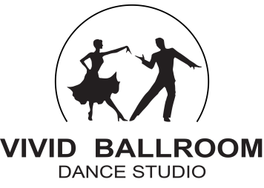

DANCE QUESTIONNAIRE

Today’s Date

Name

Address

Phone

Email

Would you like to be added to our email list? Yes No
Your address will be kept private. You will only receive communication from Vivid Ballroom.

Name

Address

Phone

Email

Would you like to be added to our email list? Yes No
Your address will be kept private. You will only receive communication from Vivid Ballroom.

Please let us know which dance style(s) you are interested in learning.

Wedding Dance Your dance song

Salsa Bachata Hustle Merengue West Coast Swing

East Coast Swing Cha-Cha Rumba Samba Argentine Tango

Waltz Foxtrot Tango Viennese Waltz Quickstep

Jive Paso Doble

Have you had prior dance instruction?

How did you hear about our studio?

